Satellite-Informed Bayesian Storm Modelling for Parametric Flood Risk Pricing

Proposal to the European Space Agency

Submitted by: National Physical Laboratory (NPL) / [Lead Applicant Organisation] In partnership with: MKM Research Labs (MKM)

Date: June 2026
Classification: Pre-Submission Draft

Overview

This proposal seeks funding and a scientific partnership from the European Space Agency (ESA) to develop a first-of-its-kind, satellite-driven Bayesian framework for continuously calibrating the storm-intensity parameters that underpin the pricing of Physical Risk Swaps (PRS) — a parametric insurance instrument modelled by MKM on the credit default swap architecture.

The background to the project is the recent work originating by the NPL, together with collaboration with the Met Office and the Global Association of Risk Professionals (GARP) who have highlighted the lack of standardisation of climate risk metrics that are leading to limitation of utility of hazard data provided by commercial vendors for the banking system that currently can only support basic disclosure and stress scenarios under the guidance of the ECB and BoE.

MKM has designed the Physical Risk Swap to address the associated model and data challenges by reverse-engineering Credit Default Swaps, enabling parties to price the cost of flood-hazard protection for an asset and its issuer. The creation of hazard events, such as floods, is calibrated using static, loosely historically derived parameters and a Hybrid Normal-Pareto storm intensity distribution. This stationarity assumption is a known and material limitation: it means that the PRS spread and payout trigger do not reflect evolving storm climatology driven by climate change.

This proposal addresses that limitation through two integrated innovations:

- Satellite-Informed Bayesian Parameter Evolution — replacing static scenario parameters with a Bayesian updating framework in which ESA Copernicus satellite observations of real flood events continuously condition and evolve the four governing storm intensity parameters, anchored and constrained by UK government river gauge data.

- AI-Governed Parameter Attribution and Portfolio Impact Engine — an artificial intelligence system that monitors parameter evolution, attributes change to its satellite-observable causes, and quantifies the downstream impact on every live PRS contract and the aggregate portfolio before any update is committed to production.

Together, these innovations make the full ESA Earth Observation archive financially actionable for the first time, and deliver a governance-grade, metrologically traceable pricing infrastructure for parametric flood risk transfer.

Problem Statement

To integrate PRS into banking, MKM has extended the use of parametric insurance that pays a fixed, pre-agreed sum when a measurable physical event crosses an agreed-upon threshold — automatically, without loss adjustment. For flood risk, the trigger is typically a river-gauge level or a satellite-derived inundation extent at a specified location. This mechanism eliminates claims disputes and accelerates capital deployment to affected parties, making parametric instruments increasingly central to sovereign, infrastructure, and corporate flood risk management in emerging markets, thereby improving access to capital markets by stripping out and hedging hazard risk.

The Physical Risk Swap (PRS) extends this architecture using the modelling conventions of credit default swaps. The PRS calculates:

- Asset-level pricing: the cost of protection against flood damage to a specific physical asset, modelled from its exposure, vulnerability, and local hazard characteristics

- Gauge-level pricing: the cost of protection referenced to a specific river gauge trigger, modelled from storm intensity distributions and the gauge's hydrological response.

- The basis: the spread between these two pricing surfaces, representing the residual trigger risk — the possibility that a flood damages the asset without breaching the gauge trigger, or vice versa

The expectation is that indices constructed from a basket of gauges will evolve into liquid, tradable assets that will support superior capital allocation and, in turn, improved credit allocation to climate-related remediation initiatives. Banks are left to measure the basis risk between the hazard-risk underwriting at the asset level and the gauges they are expected to use as hedging instruments.

Measuring basis risk is the central commercial and regulatory challenge for parametric flood insurance. Given that floods occur less frequently at the asset level than at gauges located on local minima in the catchment area, the reassessment of the basis naturally occurs infrequently, placing the solution at risk of tracking short- and medium-term weather patterns.

In a capital markets setting of intra-day trading, the PRS platform needs to operate under a near-continuous reassessment of the assumptions embedded in the storm modelling. This feature aligns closely with the strategic desire of the ESA to act as an early-warning service to enable immediate remediation actions that save lives and minimise asset damage.

The Stationarity Problem

The PRS platform is currently available as an open-source solution on the MKM-Research-Labs GitHub site. The PRS pricing engine is fed by the MKM Storm Intensity Distribution Model (MKM-SI-001), a Hybrid Normal-Pareto probability distribution governed by four parameters:

- μ (base mean): Controls the central tendency of storm intensity
- σ (base standard deviation): Controls the spread of typical events
- u (tail threshold): The intensity level above which extreme Pareto scaling engages
- ξ (tail index): Controls the heaviness of the extreme tail — the single most influential parameter for return-period intensities and therefore PRS pricing

These parameters are currently calibrated to a historical storm catalogue using maximum-likelihood estimation (body) and Hill estimation (tail), and then held constant within each of five predefined scenario families. The model documentation explicitly flags stationarity as a primary limitation: it does not account for climate change trends or decadal variability driven by ENSO, NAO, or AMO oscillations.

The consequence for PRS pricing is outlined in their model risk documentation:

- Spread under-pricing when storm climatology is intensifying — the tail index ξ is too high (thin tail), under-stating extreme event frequency.

- Trigger mis-calibration when the threshold u does not reflect the gauge level distribution under current climate conditions.

- Basis misstatement when asset-level and gauge-level models diverge due to spatially heterogeneous shifts in storm behaviour that a single national parameter set cannot capture

The Data Opportunity

ESA’s Copernicus programme provides a systematic, continuous, globally consistent archive of satellite observations capable of characterising individual storm events with sufficient fidelity to inform parameters of the storm intensity distribution. The Sentinel-1 SAR constellation — operating since 2014, cloud-penetrating, and capable of day-and-night operation — delivers observed flood extents within hours of inundation onset. The Copernicus Emergency Management Service (CEMS) Global Flood Monitoring (GFM) service produces near-real-time flood maps from every Sentinel-1 acquisition, providing a consistent, near-decade-long flood event catalogue.

Simultaneously, the UK National River Flow Archive (NRFA), operated by the UK Centre for Ecology and Hydrology, provides freely accessible, quality-controlled daily mean flow and peak flow data from over 1,600 gauging stations across the United Kingdom — precisely the gauge network that underpins PRS trigger calibration.

The scientific and pre-commercial opportunity is to connect these two data streams — satellite-observed flood events and gauge-measured hydrological responses — through an AI-mediated Bayesian framework that continuously updates the PRS pricing parameters to reflect realised storm behaviour.

Conceptual Architecture

The proposed system operates as a closed-loop Bayesian calibration engine positioned between the ESA data infrastructure and the PRS pricing stack. Its operation can be described in five stages:

- Stage 1 — Event Detection Sentinel-1 SAR acquisitions are continuously monitored via the Copernicus Data Space Ecosystem (CDSE) API. When CEMS GFM produces a new flood extent product, an event is registered. The event is characterised by its spatial footprint, inundation area, onset rate, peak extent, and duration — all derivable from the time-sequential SAR archive using the Copernicus DEM for terrain context.

- Stage 2 — Intensity Scoring The observed physical event must be placed on the MKM normalised intensity scale (0–100). This requires a transfer function that maps multi-dimensional physical observables (inundation area in km², duration in hours, rate of onset, spatial coherence across the catchment) to a scalar intensity score. Because the satellite observes flood extent — which the MKM chain itself produces from gauge levels through its hydrological (Hydrograph, MKM-HG-001) and hydraulic (Flood Propagation) models — the transfer function is effectively an inversion of that physical chain. It must be validated for consistency against it. This transfer function is the most scientifically challenging component of the system, and the primary locus of NPL's metrological contribution. The function must:
- Produce a traceable, uncertainty-quantified intensity score with defensible confidence intervals.
- Be consistent with the existing MKM model's intensity scale so that updates are compatible with the established pricing architecture.
- Be anchored by concurrent NRFA gauge observations, which provide an independent physical measurement of flood severity at the trigger point.

- Stage 3 — Bayesian Parameter Update The intensity score, together with its uncertainty, is used to update the four governing parameters using Bayesian inference. The current parameter set constitutes the prior; the observed intensity score provides the likelihood; the posterior becomes the updated parameter set for the next pricing cycle. This approach is well-established in extreme value hydrology — hierarchical Bayesian GEV frameworks have demonstrated superior flood quantile estimation compared to classical methods, particularly for constraining tail behaviour with limited data. The update is event-triggered, not time-scheduled: parameters evolve in response to observed reality, not the passage of calendar time. Between events, the parameters remain stable. This design preserves the governance integrity of the Tier 1/2 model chain while ensuring that material new information is incorporated promptly.

- Stage 4 — Gauge Constraint NRFA gauge data serves a dual role. First, it acts as a likelihood constraint on the Bayesian update. If the satellite-derived intensity score implies a 1-in-50-year event but the gauge record indicates a 1-in-10-year event at the relevant station, the update is moderated accordingly. Second, it provides a direct calibration anchor for the gauge-level PRS pricing surface, ensuring that the asset-level and gauge-level models remain coherently coupled. This is the mechanism by which basis risk is most directly controlled.

- Stage 5 — Impact Attribution and Portfolio Governance. Before any updated parameter set is committed to the live PRS pricing engine, the AI attribution system computes the full downstream impact across both arms of the model chain. The gauge-level (trigger) arm runs Storm Intensity Distribution (MKM-SI-001) → Storm-Gauge Response Model (MKM-SG-001) → GEV Hazard Curve Model (MKM-GH-001) → PRS Analytical Pricing Model (MKM-PR-001). The asset-level (damage) arm branches at the gauge response through the hydrological and hydraulic models — Hydrograph (MKM-HG-001) → Flood Propagation → Property Flood Response (MKM-PF-001) → Depth-Damage Curve (MKM-DD-001) — before recombining at the PRS pricing engine. Since the basis is the spread between these two arms, attributing each parameter change to its separate effect on each arm is precisely what makes the basis impact explicit. For every live PRS contract, the system produces a delta report showing the change in spread, trigger probability, and expected payout under the proposed updated parameters. The aggregate portfolio net present value change is computed and presented to the governance function for review. Only upon human approval is the update committed.

Workstream Structure

Workstream 1 — Transfer Function Development and Metrological Calibration

Objective: Construct a validated, traceable transfer function mapping ESA satellite observables to the MKM intensity scale, constrained by NRFA gauge data.

Activities:
- Ingest the Sentinel-1 GRD archive (2014–present) from CDSE for UK flood catchments, using the S3 and openEO APIs for cloud-native processing at NPL compute infrastructure.
- Extract flood event catalogues using CEMS GFM products as the primary detection layer, supplemented by independent Sentinel-1 backscatter change detection
- Characterise each detected event across five physical dimensions: peak inundation extent, total inundation volume (derived with Copernicus DEM EEA-10), event duration, onset rate, and catchment spatial coherence.
- Match each satellite-detected event to concurrent NRFA peak flow and gauge level observations at co-located stations, constructing a paired satellite-gauge event dataset.
- Train and validate the AI transfer function — mapping the five-dimensional physical feature vector to a scalar intensity score with calibrated uncertainty — using NPL standards for uncertainty propagation.
- Validate the transfer function against the existing MKM historical scenario calibration (μ=40, σ=12, u=60, ξ=3.0) to ensure scale consistency.

Key output: A validated, governance-ready transfer function with traceable uncertainty bounds, certified by NPL as fit for use in a Tier 2 pricing model.

Workstream 2 — Bayesian Parameter Evolution Engine

Objective: Implement and validate the Bayesian updating framework that evolves the four MKM parameters in response to observed events.

Activities:

- Establish the Bayesian prior from the existing five MKM scenario families, treating the historical scenario as the initial prior distribution over (μ, σ, u, ξ)
- Define the likelihood function for each parameter, informed by the transfer function output from WS1 and the NRFA gauge constraint.
- Implement the posterior update using Markov Chain Monte Carlo (MCMC) sampling, consistent with established Bayesian GEV frameworks for flood frequency analysis.
- Test the update mechanics against a held-out set of known UK flood events (e.g. 2019–20 England floods, 2021 Yorkshire flooding) to verify that the Bayesian updates move parameters in physically meaningful directions.
- Define and implement governance gates: criteria for classifying an update as material (requiring human review) versus immaterial (logged but not propagated), informed by the model's existing sensitivity analysis showing that ξ changes near 1.0 have non-linear, amplified effects.
- Produce a new extended scenario family — a Dynamic Climate Scenario — that represents the current posterior parameter distribution as a living, updatable member of the MKM scenario family table.

Key output: A functioning Bayesian update engine integrated with the MKM Storm Intensity Distribution Model, with documented governance triggers and a validated update audit trail.

Workstream 3 — AI Attribution and Portfolio Impact Engine

Objective: Build the AI system that quantifies the downstream PRS portfolio impact of each proposed parameter update and supports the governance review workflow.

Activities:

- Instrument the full MKM model chain — the gauge-level arm (MKM-SI-001 → MKM-SG-001 → MKM-GH-001 → MKM-PR-001) and the asset-level arm that branches through the hydrological and hydraulic models (MKM-SG-001 → Hydrograph MKM-HG-001 → Flood Propagation → Property Flood Response MKM-PF-001 → Depth-Damage MKM-DD-001 → MKM-PR-001) — to accept parameter perturbations and propagate them to PRS contract-level outputs
- Develop the attribution engine: for any proposed (Δμ, Δσ, Δu, Δξ), compute the partial derivatives of spread, trigger probability, and expected payout with respect to each parameter, attributing total impact to its constituent drivers.
- Implement the portfolio delta report: for each live PRS contract, report the changes in mark-to-market value, spread, trigger exceedance probability, and expected payout under the proposed updated parameters.
- Build the governance workflow interface: present the attribution report and portfolio delta to the approving authority with sufficient context (event summary, satellite evidence, gauge data) to support an informed decision; log all approvals and rejections for the regulatory audit trail.
- Design and implement the model monitoring dashboard: track the evolution of (μ, σ, u, ξ) over time, alert when parameters drift beyond predefined bands relative to the scenario family ladder, and flag any parameter combination that approaches the ξ < 1.5 region where the distribution has infinite variance

Key output: A production-grade AI attribution and governance engine, integrated with the PRS platform, capable of processing parameter updates within the existing Tier 1/2 model risk governance framework.

Data Architecture
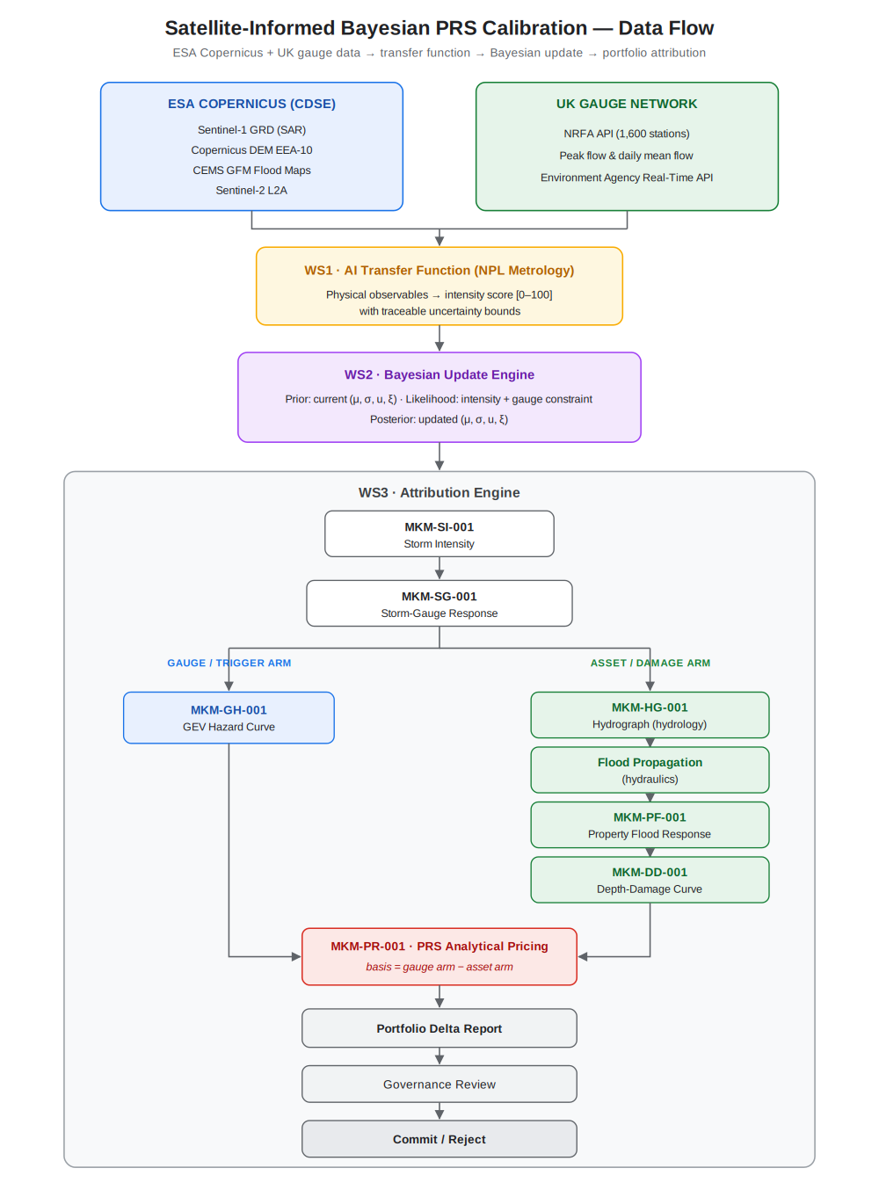

Primary ESA Data Stack

Data Layer | Source | Access Method | Role
Sentinel-1 GRD (COG_SAFE) | Copernicus Data Space Ecosystem | S3 / openEO API | Event detection, flood extent characterisation
Copernicus DEM EEA-10 (10 m) | CDSE | S3 | Inundation volume estimation, flow routing
CEMS GFM Products | CEMS Early Warning Data Store | REST API | Primary flood event catalogue, detection benchmark
Sentinel-2 L2A | CDSE | STAC / openEO | Pre-event land cover, optical validation (clear sky)
Copernicus Land Monitoring — Imperviousness | land.copernicus.eu | WCS | Urban runoff characterisation for catchment context

All ESA data is available free of charge under the Copernicus open data policy following registration. The cloud-native CDSE infrastructure, which holds over 78 petabytes of immediately accessible data, enables processing at scale without bulk data transfer by using the openEO API for server-side computation.

UK Government Gauge Data

Data Layer | Source | Access Method | Role
Daily mean flow | NRFA API (CEH) | REST API / CSV | Gauge constraint on Bayesian update
Peak flow dataset | NRFA API (CEH) | REST API / WINFAP | Flood frequency baseline for prior calibration
Near-real-time gauge levels | Environment Agency API | REST API | Live trigger monitoring for PRS event detection

The NRFA API provides freely accessible daily mean flows, catchment daily rainfall, and peak flow data from over 1,600 UK gauging stations in JSON or CSV format. This data is openly licensed under the Open Government Licence.

Alignment with ESA Priorities

This project directly instantiates ESA's Earth Action ambition: translating satellite data into tangible societal and economic decisions. The PRS is a financial mechanism for flood risk transfer — making flood protection economically accessible and efficiently priced. Better-priced parametric insurance instruments accelerate capital deployment to flood-affected communities and assets, reducing the protection gap, one of the most significant economic consequences of climate change.

This proposal aligns directly with the open Horizon Europe call HORIZON-CL6-2026-03-GOVERNANCE-01: "Develop Earth Intelligence solutions using environmental observations and state-of-the-art AI for sustainable competitiveness and policy making". Specifically:
- Intensive use of Copernicus EO data: Sentinel-1 SAR, Copernicus DEM, and CEMS GFM are the primary data inputs throughout all three workstreams
- AI-driven decision support tools for private actors: The PRS pricing engine and attribution system directly serve financial institutions, insurers, and corporate treasuries managing flood exposure.
- Co-design with end-users: The PRS platform operator (project lead) is an end-user co-designer, ensuring fit-for-purpose outputs from the first workstream
- Explainability and robustness: The Bayesian attribution architecture provides explicit, auditable explanations for every parameter change and its portfolio consequences
- Collaboration with ESA FutureEO: The project explicitly builds on and extends the CEMS GFM service and the Copernicus Data Space Ecosystem infrastructure, with commitment to ESA FutureEO coordination activities

The project also aligns with ESA Phi-Lab UK Pillar 1: Fight climate change with space technology. Parametric flood insurance priced on satellite-derived, climate-evolving storm parameters is a direct commercial application of space technology to climate adaptation. Phi-Lab UK offers funding of €200,000–€225,000 per project for UK-based applicants from private organisations, research institutions, and academia, with NPL and the project lead constituting an eligible UK-based consortium.

Innovation and Novelty

This project is novel across three dimensions:

- Scientific novelty. While Bayesian GEV frameworks for flood frequency analysis are established in hydrology, their application to the continuous, event-triggered calibration of a parametric pricing model parameter set — specifically using the Hybrid Normal-Pareto intensity scale of the MKM architecture — has not been demonstrated. The integration of SAR-derived flood observables as the likelihood function in such an update represents a genuinely new methodological contribution.

- Commercial novelty. The use of Earth Observation data as a dynamic input to an open source structured financial product's pricing engine — rather than solely as a payout trigger — is a frontier application of satellite data in capital markets. The PRS-based quantification enabled by co-registered satellite and gauge observations represents a step change in the precision of parametric flood pricing.

- Governance novelty. The AI attribution engine — which quantifies the downstream portfolio impact of satellite-informed parameter changes before they are committed — establishes a new standard for model risk governance in EO-informed financial applications. The architecture explicitly preserves the Tier 1/2 governance hierarchy of the existing MKM model framework, demonstrating that satellite-driven dynamism and financial regulatory compliance are not in tension.

Known Limitations and Risk Mitigations

Limitation | Mitigation
Transfer function uncertainty: mapping physical observables to the normalised [0–100] scale involves irreducible modelling judgement | NPL metrological framework provides traceable uncertainty bounds; Bayesian update propagates this uncertainty into parameter posteriors rather than treating the score as exact
Sentinel-1 archive length (from 2014): ~12 years is insufficient to independently estimate decadal or centennial return periods | NRFA peak flow archive (from 1960s at many stations) constrains long-return-period tail behaviour; the Bayesian prior from the existing MKM historical scenario encodes pre-satellite climatological knowledge
Independence assumption in the storm intensity model: temporal clustering of storm events is not captured in the current MKM architecture | WS2 Bayesian update operates on individual event observations; cluster sequences are characterised using the storm sequence parameters documented in test results (MKM-SS-001)
UK-focus of NRFA gauge data: limits immediate applicability to UK PRS portfolios | Initial scope is explicitly UK; extension to European gauge networks (EuroWQMS, GRDC) is a future phase deliverable
Stationarity of the transfer function itself: the satellite-to-intensity mapping may itself evolve | Annual model review of transfer function parameters is included in the project governance cycle, consistent with existing SR 26/2 requirements for annual review

Conclusion

The convergence of ESA's systematic satellite observation programme, the UK's world-class river gauge network, and advances in Bayesian inference and AI attribution creates a unique opportunity to develop a new generation of climate-responsive parametric flood-pricing instruments.
The Physical Risk Swap — already a sophisticated financial engineering achievement modelled on credit default swap architecture — has a clear and addressable limitation: its governing storm-intensity parameters do not evolve in response to observed reality.

This proposal provides the scientific framework, the data infrastructure, and the governance architecture to close that gap.
By making the ESA Copernicus archive financially actionable through metrologically rigorous AI, this project delivers direct societal impact for ESA by improving flood risk transfer, advances the scientific state-of-the-art in Bayesian EO-to-parameter calibration, and establishes a replicable governance model for satellite-informed financial products that will extend far beyond flood risk.
The project is ready to proceed. The model architecture is in place, the financial modelling and governance infrastructure is in place, and the partnership between domain expertise (MKM Research Labs), measurement science (NPL), and satellite data (ESA) is uniquely configured to deliver this outcome.

The Earth Observation ingestion, the metrologically calibrated transfer function, the Bayesian parameter-evolution engine, and the AI attribution engine are the funded deliverables of the workstreams above; the readiness review in Part B sets out precisely which foundations already exist to build upon.

